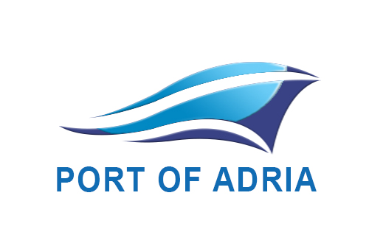

PORT OF ADRIA FORMA UPITA

PORT OF ADRIA JSC – SEKTOR KOMERCIJALE
1. | Naziv tereta / vrsta robe:
2. | Fizičke karakteristike tereta:
 | Dimenzije:
 | Težina:
 | Pakovanje:
3. | Ukupna planirana količina pretovara / lotovi:
4. | Dinamika dopreme / otpreme tereta:
5. | Manipulacija:
6. | Dodatne usluge – posebni zahtjevi u procesu pretovara ili skladištenja robe:
7. | Usluge skladištenja tereta:
8. | Karakteristike broda i datum/vrijeme dolaska u luku:
9. | Zemlja uvoza i izvoza:
10. | IMO teret (potrebna dostava MSDS):
11. | Slike tereta (osim za standardno paletizovani/nepaletizovani teret)
12. | Napomena:
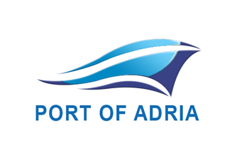

PORT OF ADRIA INQUIRY FORM

PORT OF ADRIA JSC – COMMERCIAL DEPARTMENT
1. | Cargo name / type:
2. | Cargo specifications:
 | Dimensions:
 | Weight:
 | Packaging:
3. | Total volumes planned / lots:
4. | Dynamics of cargo transshipment:
5. | Handling activity requested:
6. | Additional services - special requests during handling or storage of cargo:
7. | Storage requirements:
8. | Vessel characteristics and date / time of arrival to port:
9. | Country of export and import:
10. | IMCO class (MSDS is required):
11. | Cargo images (except for standard palletized / non-palletized cargo)
12. | Note:

